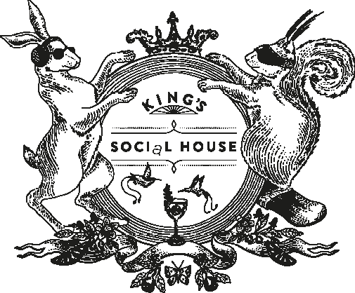

TO FINISH
DESSERT
Classic Apple Tarte Tatin ‘for two’ Vanilla Ice Cream A.C.G | 25

Cherry & Vanilla Flaming Baked Alaska Pistachio C.G.H.O. | 22

Crème brûlée, Fruit Compote
C.G.O | 18

Bitter Chocolate Tart, Tahittian Vanilla Ice Cream A.C.H.G. | 18

Please inform your waiter of any allergy or dietary requirements All prices are quoted in Swiss Francs and include 7.7% VAT
WWW . KINGSSOCIALHOUSE.COM

