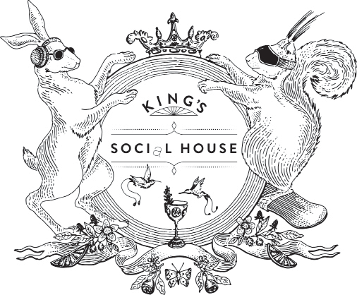

JARS TO SHARE
V. Feta, Coriander, Pistachio Dip, Crudités | 14 H.G
V. Hummus, Spiced Aubergine | 14 N
V. Cured Salmon Rilette, Crème Fraiche, Citrus | 20 G.D
Confit Ham Hock, Piccalilli | 22

TO START
Ceviche Tower, Char, Lobster, Scallop | 66 B.D
Raw Beef Tartar, Cured Egg, Truffle, Horseradish | 48 C.F.M.O
Lobster Salad, Mangetout, Ginger, Spring Onion, Ponzu
V. Roasted Wild Mushroom, Smoked Egg Yolk, Cep Toast | 32 A.G
Cured Halibut, Avocado, Sunflower, Shiso
V. Truffled Morels, Gruyere, Emmental, Pangritata | 42 A.G.O.M
Foie Gras & Pork Terrine, Onion Jam, Piccalilli | 36 A.C.M.O
Wood Fired Scallops, Japanese Dressing, | 32 (for three) 64 (for six) G.R.O

TO FOLLOW
Grilled Lobster, Green Salad, Truffle & Parmesan French Fries | 45 (Half) 88 B.G
Rib-Eye Steak, Herb Pesto, Jerusalem Artichokes, Béarnaise | 125 C.G.O
Seabream, Lobster Risotto, Confit Lemon
Roast Turbot, Pearl Barley, Cep, Arugula Pesto | 120 B.G.A
Roasted Chicken, Carrot Purée, Chicken Crumb, Spinach | 58 A.G.O
V Asparagus, Artichoke, Creamed Spinach, Egg (cooked Sukiyaki) | 39 C.G.O
Veal & Foie Gras Burger, Churchill Sauce, Cheese, Bacon, Truffle & Parmesan Fries | 60 A.C.G.O.M

Add Black Truffle To Any Dish | 20 per gram Add Caviar To Any Dish | 11 per gram

Please inform your waiter of any allergy or dietary requirements
All prices are quoted in Swiss Francs and include 7.7% VAT
WWW . KINGSSOCIALHOUSE.COM

ALLERGENE / ALLERGENS
- Glutenhaltiges Getreide / Grain with gluten
- Krebstiere / Shellfish
- Eier von Geflügel / Eggs from chicken
- Fisch / Fish
- Erdnüsse / Peanuts
- Sojabohnen / Soya beans
- Milch vom Säugetieren / Milk from mammal
- Schalenfrüchte / Nuts L. Sellerie / Celery
  - Senf / Mustard
  - Sesam Samen / Sesame seeds
  - Schwefeldioxid und Sulfite / Sulphur dioxide and sulphites
  - Lupinen / Lupin
R. Weichtiere / Mollusca

FLEISCHHERKUNFT / MEAT ORIGINE
Kalb / Veal CH
Rind / Beef CH
Geflügel / Poultry CH, FRA*
Wild / Game AUT*
Lamm / Lamb AUS*
Schwein / Pork ESP*

*Kann mit nichthormonellen Leistungsförderern, wie Antibiotika, erzeugt worden sein
*May have been produced with non-hormonal enhancers such as antibiotics

FISCHHERKUNFT / FISH ORIGINE
Kaviar / Caviar CHN
Lachs / Salmon GB
Wolfsbarsch / Seabass FR, Atlantic
Seezunge / Sole NL/Northeast Atlantic
Steinbutt / Turbo GB/Northeast Atlantic
Dorade / Dorade EU/Northeast Atlantic
Hummer / Lobster CAN
Garnelen / Prawn VIE, THA
Carabineros / Carabineros MAR
Scampi / Scampi RSA/Southeast Pacific

